# SWE 482 Lab Assignment (#3) 1st Semester 2017-2018

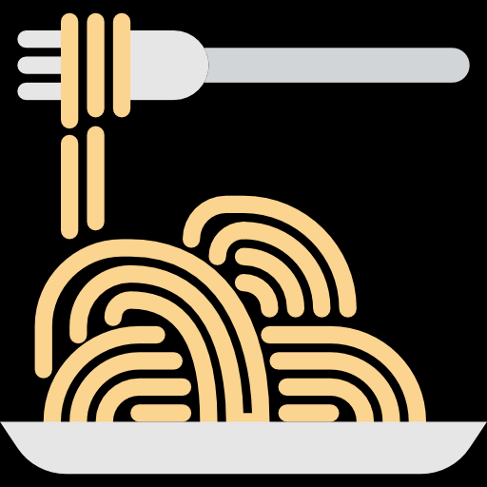

**NARS Restaurant**

**Group #4:**

Norah AlKhunifer, 435201094

Renad AlMalki, 435201240

Alzahra​ ​AlHowaish, 435201808

Sara Al-Meshari, 435202339

**Table of figures:**

Figure 1:"main page" 1

Figure 2:"resrevation list " 2

Figure 3:"waiters tables " 2

Figure 4:"order menu " 2

Figure 5:"food main menu" 3

Figure 6:"food menu" 3

Figure 7:"table bill " 3

Figure 8:"main screen " 5

Figure 9:"waiters tables " 5

Figure 10:"resrevation list" 5

Figure 11:"book a reservation form" 6

Figure 12:"main table menu " 6

Figure 13:"order menu " 6

Figure 14:"main food menu" 7

Figure 15:"food menu" 7

Figure 16:"bill" 7

**Paper prototype:**

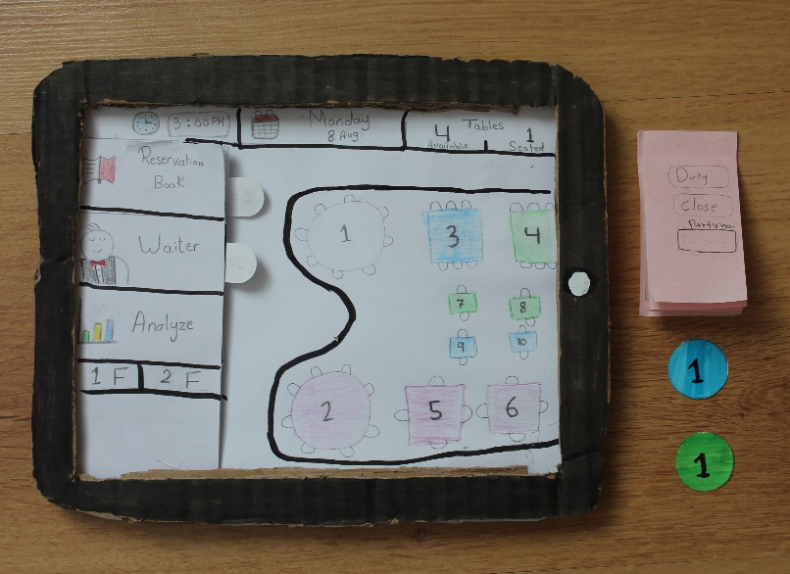

Figure 1:"main page"

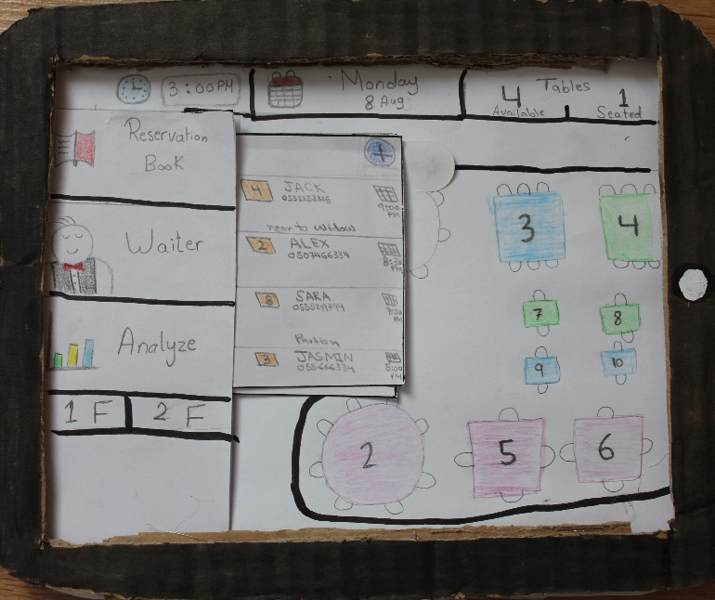

Figure 2:"resrevation list "

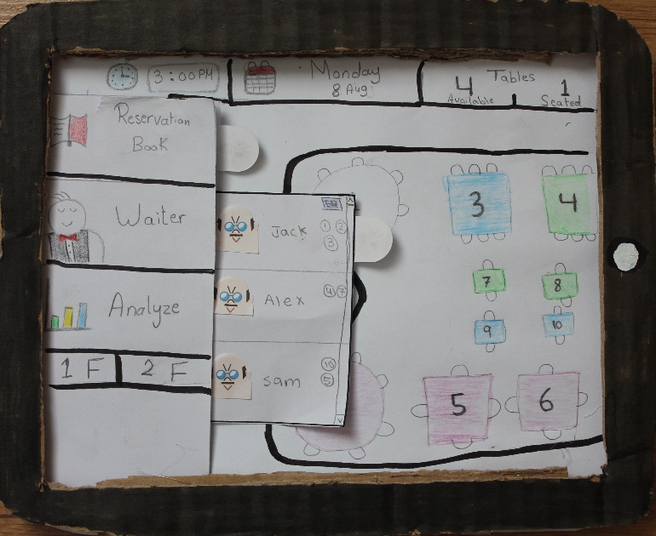

Figure 3:"waiters tables "

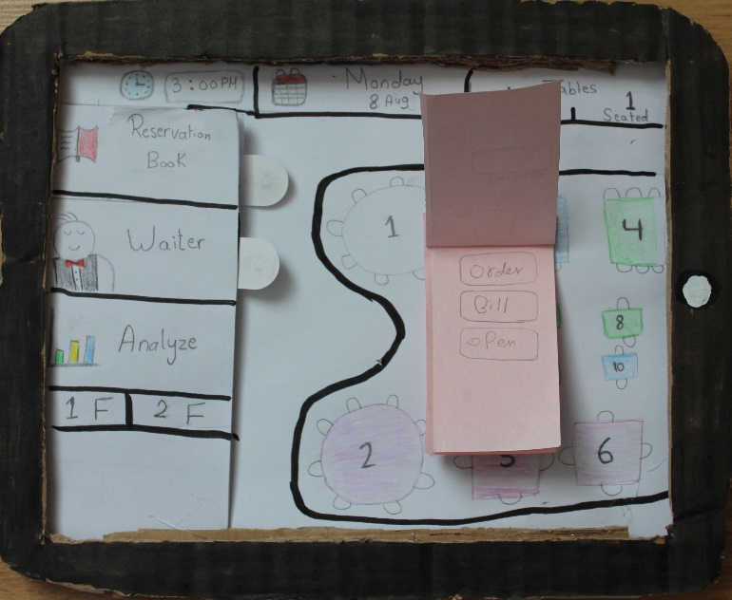

Figure 4:"order menu "

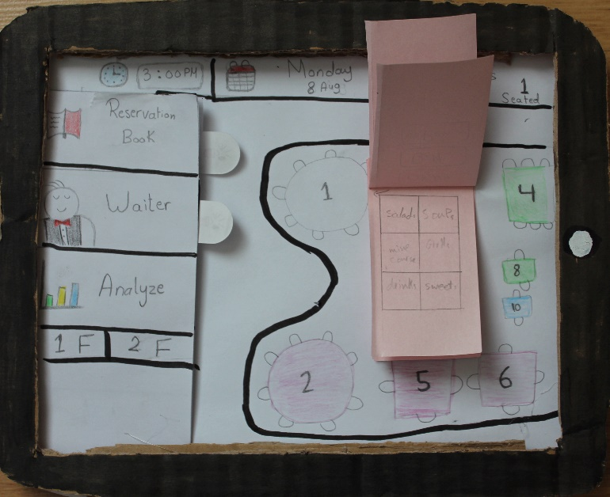

Figure 5:"food main menu"

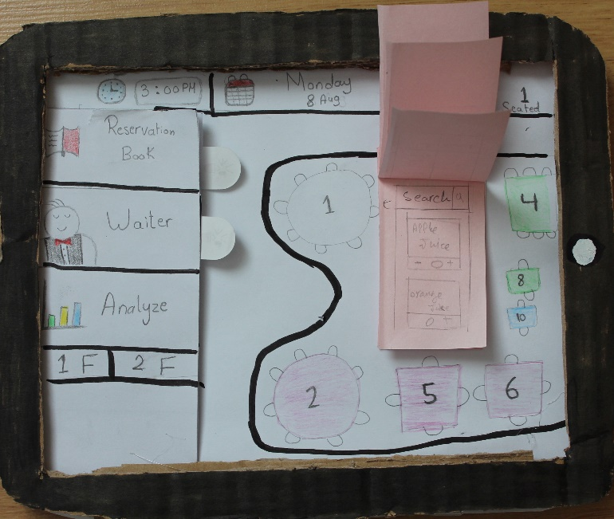

Figure 6:"food menu"

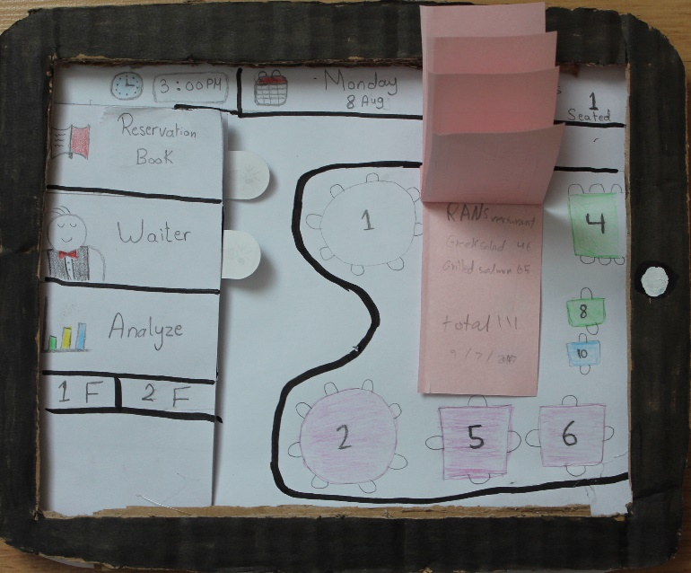

Figure 7:"table bill "

**Dynamic prototype:**

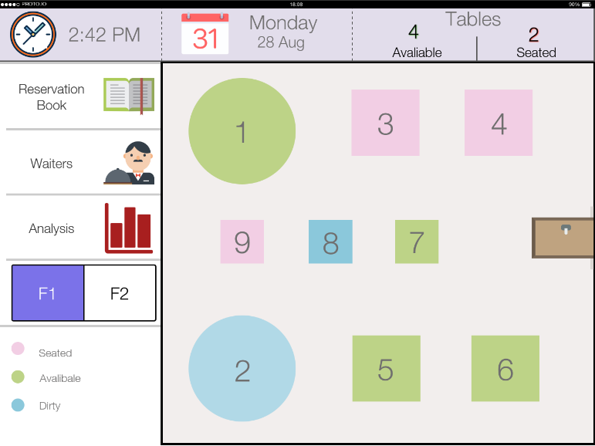

Figure 8:"main screen "

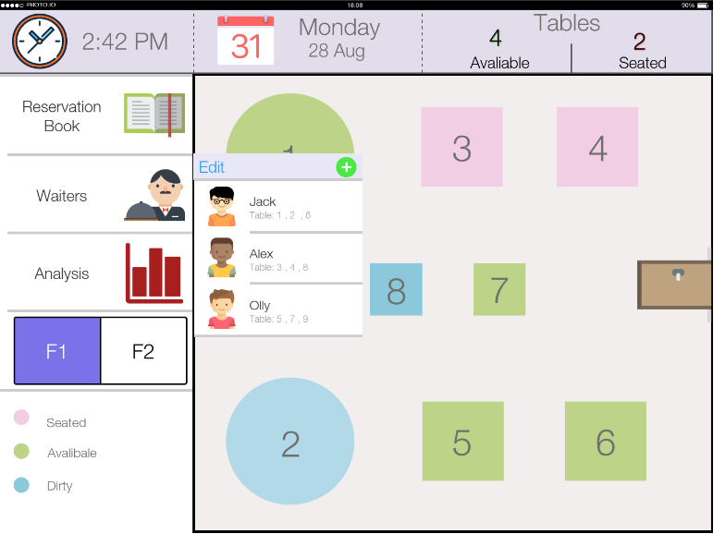

Figure 9:"waiters tables "

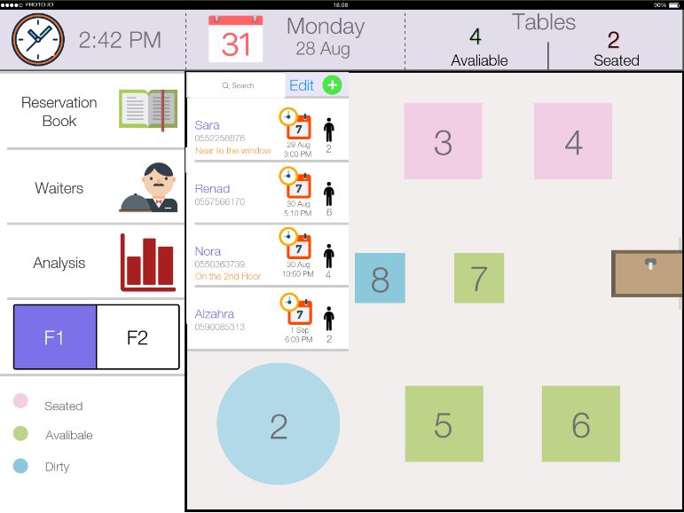

Figure 10:"resrevation list"

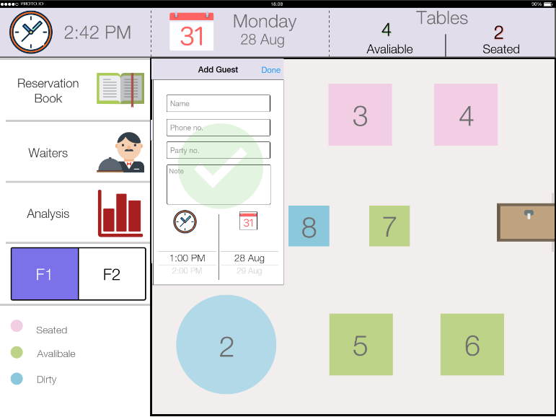

Figure 11:"book a reservation form"

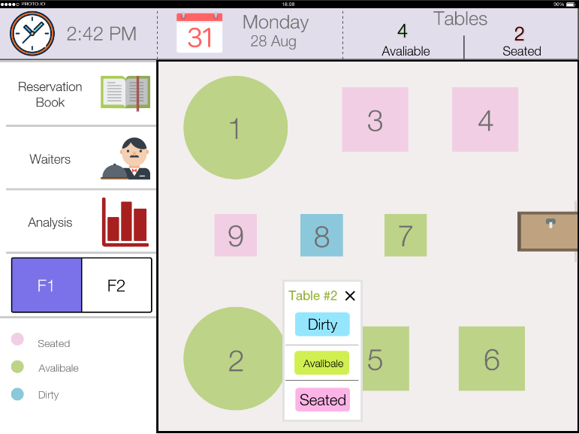

Figure 12:"main table menu "

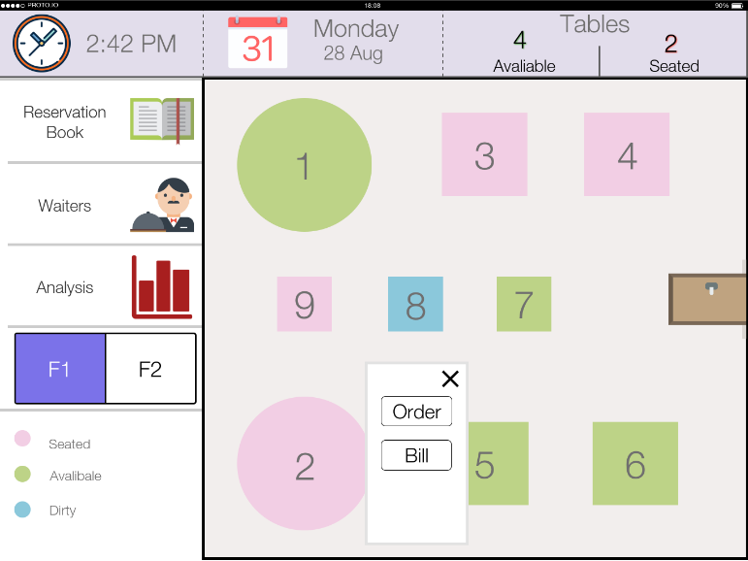

Figure 13:"order menu "

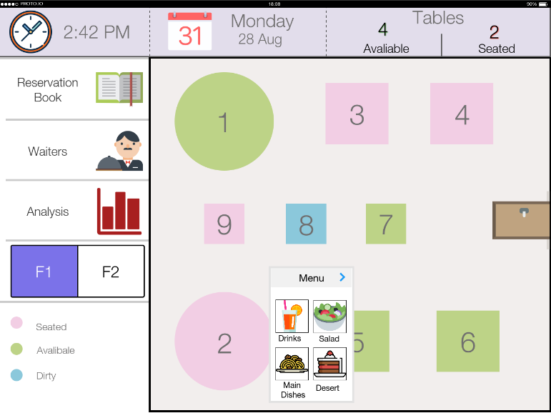

Figure 14:"main food menu"

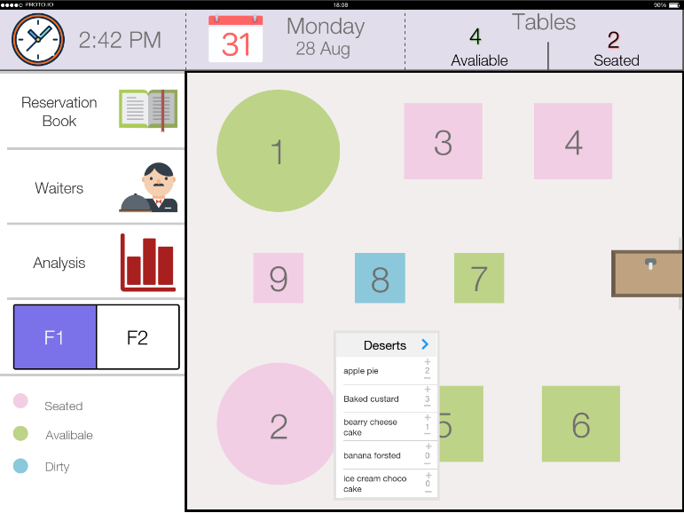

Figure 15:"food menu"

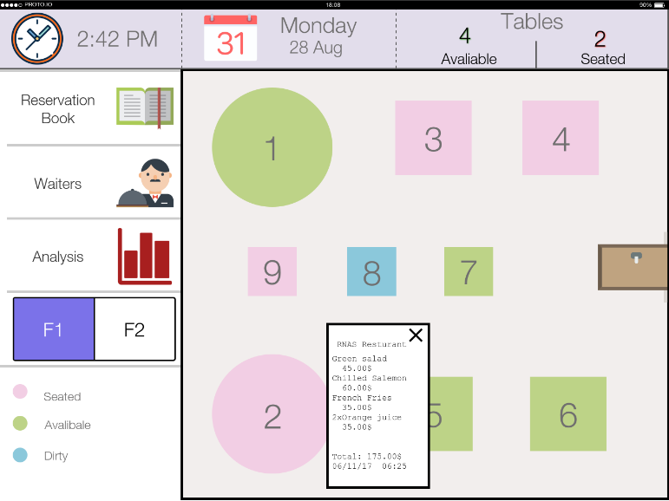

Figure 16:"bill"